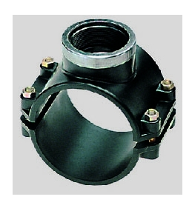Figure 1: https://www.google.com/url?sa=i&url=https%3A%2F%2Fwww.piscineo.com%2Fcollier-prise-en-charge-renforce-63-1.html&psig=AOvVaw2uv-z7qk68b6QYSRhgCrRq&ust=1634214283460000&source=images&cd=vfe&ved=0CAkQjRxqFwoTCMi8n-Gwx_MCFQAAAAAdAAAAABAI
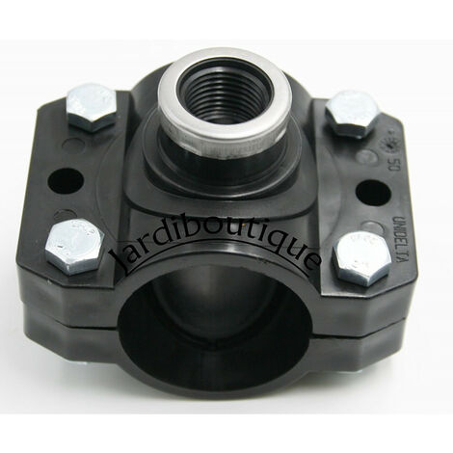Figure 2: https://www.manomano.fr/p/collier-de-prise-en-charge-renforce-50-mm-3-4-4-vis-de-serrage-10035921?model_id=10035921

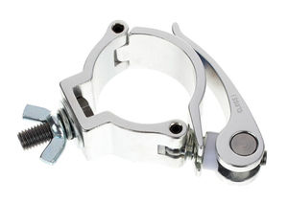Figure 4: https://www.google.com/url?sa=i&url=https%3A%2F%2Fwww.prozic.com%2Fwww2%2Finfo_promo_CLAMPQUICK_Crochet-clamp.html&psig=AOvVaw3jqpUS64wHCCh74uFJq1Uo&ust=1634213480483000&source=images&cd=vfe&ved=0CAkQjRxqFwoTCPCGjeKtx_MCFQAAAAAdAAAAABAK
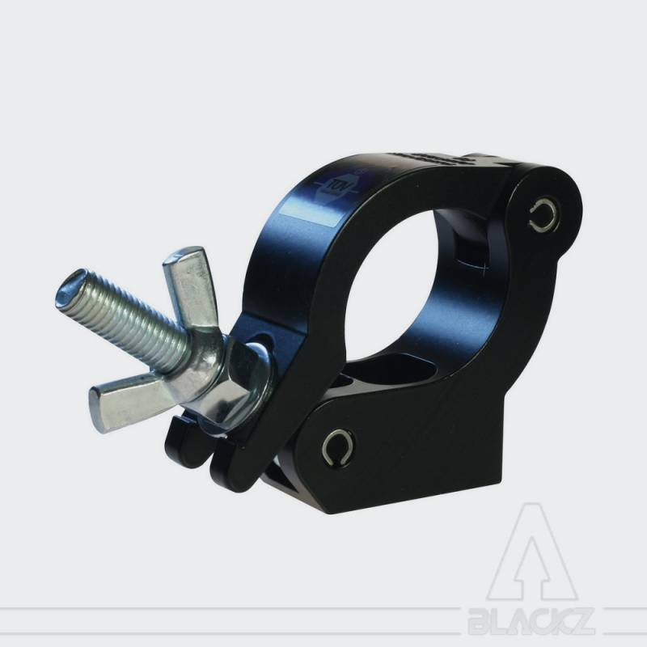Figure 3: https://www.google.com/url?sa=i&url=https%3A%2F%2Fblackz.fr%2Ffr%2Ftubes%2F374-collier-de-serrage-sur-tube-50mm-fr.html&psig=AOvVaw3jqpUS64wHCCh74uFJq1Uo&ust=1634213480483000&source=images&cd=vfe&ved=0CAkQjRxqFwoTCPCGjeKtx_MCFQAAAAAdAAAAABAR
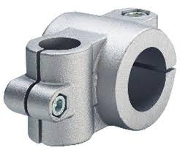Figure 5: https://www.google.com/url?sa=i&url=https%3A%2F%2Fwww.hellopro.fr%2Femile-maurin-elements-standard-mecaniques-518148-2015723-societe.html&psig=AOvVaw1r-VzOTwZGJWxlwUjktbIi&ust=1634212967753000&source=images&cd=vfe&ved=0CAkQjRxqFwoTCIDHyvGrx_MCFQAAAAAdAAAAABAX
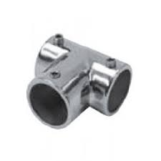Figure 7: https://www.google.com/url?sa=i&url=https%3A%2F%2Fwww.fix-in.com%2Faccessoires-tube%2F188-collier-de-serrage-d-25-mm-serie-legere-inox-a2-aisi-304.html&psig=AOvVaw1r-VzOTwZGJWxlwUjktbIi&ust=1634212967753000&source=images&cd=vfe&ved=0CAkQjRxqFwoTCIDHyvGrx_MCFQAAAAAdAAAAABAe
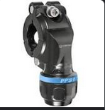Figure 6: https://www.google.com/aclk?sa=l&ai=DChcSEwiHoJzrs8fzAhXT-FEKHa2FA2kYABA2GgJ3cw&sig=AOD64_1vFC9QJvMHdKMhnV2dKjg1yD0XlA&adurl&ctype=5&ved=2ahUKEwjI047rs8fzAhXx1-AKHQaoCwsQuxd6BQgBEPUD

